In my final project, I am doing a time-space visualization. I am collected weather data from 20 weather stations from the [NOAA](https://www.noaa.gov/) website, pre-process the data, and visualize them based on the location of the stations. Below I am reporting the performed activities:

1_ Data Collection:

I collected the weather data from NOAA website. For that I prepared an instruction that shows how I selected the stations.

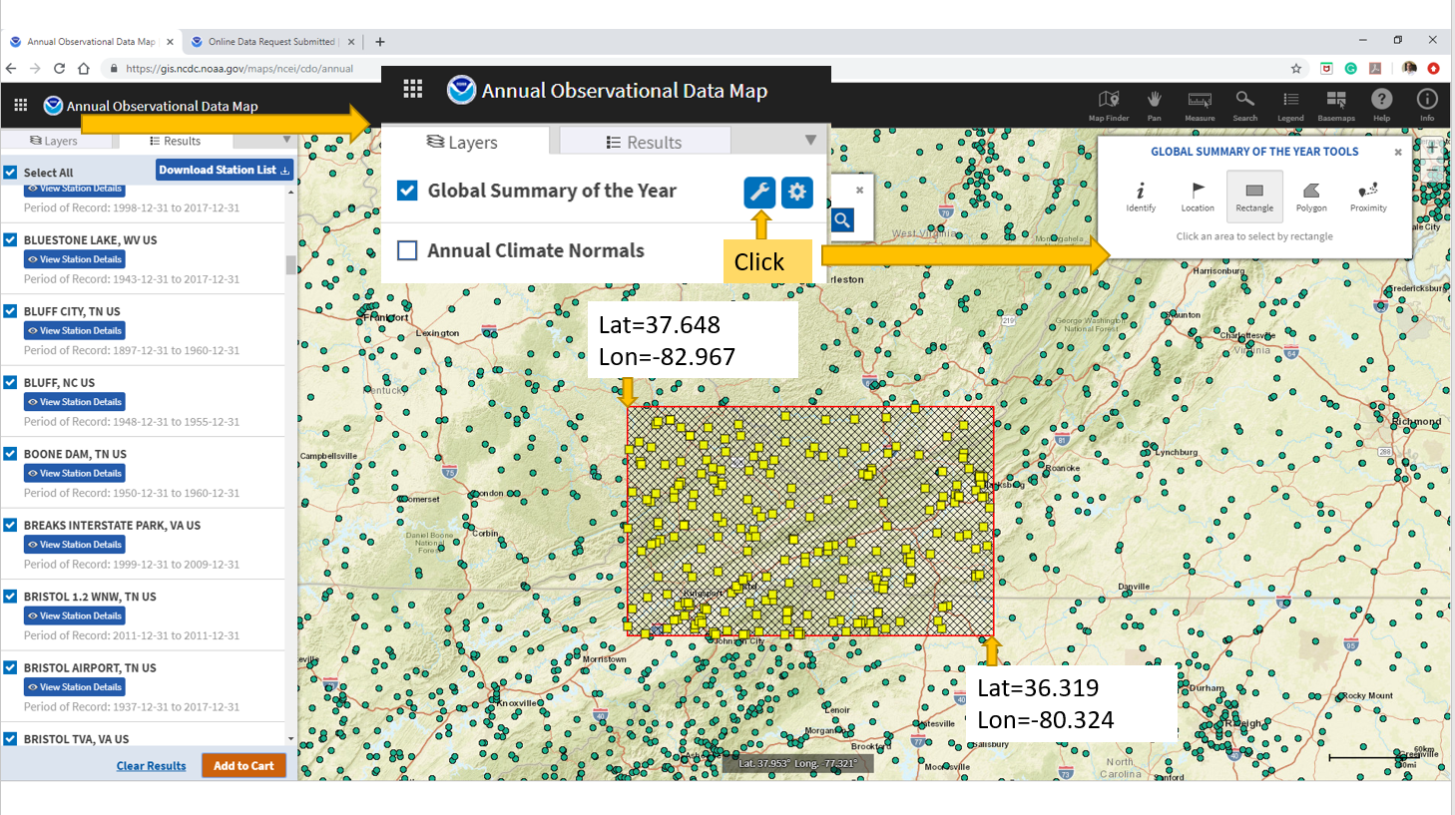

I collected TMAX (maximum temperature recorded in a day), TMIN (minimum temperature recorded in a day), PRECIPITATION (the amount of precipitation recorded in a day), and SNOW (The amount of snow recorded in a day) from the shown weather stations for 5 years (2015 – 2020). Then, I cleaned the dataset and removed the stations that do not have enough records. I cleaned the collected dataset and merged them and created a single dataset to be used in the project.

2_ First Visualization – A Scatter Plot for Weather Stations

As my first visualization, I used a scatter plot to geographically visualize the location of considered stations. The below snapshot shows this visualization as well as the created objects:

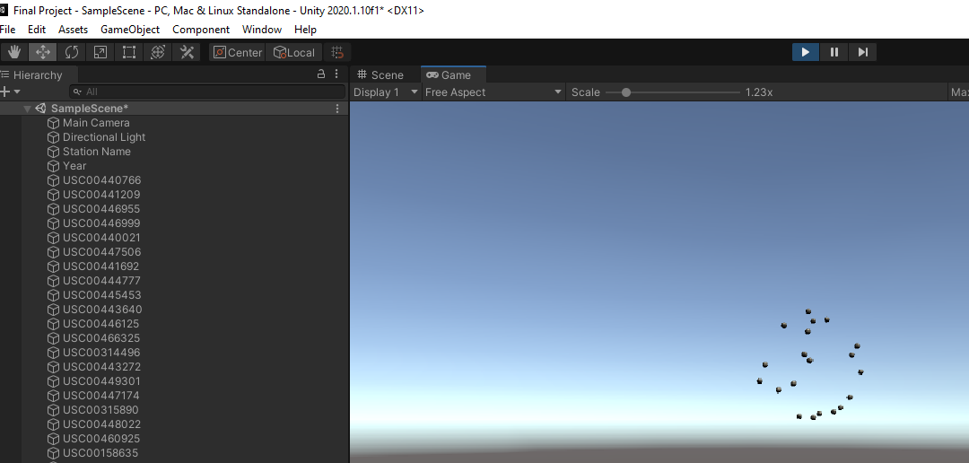

As it can be seen, after data cleaning, 20 weather stations are remaining. I used the reported latitude and longitude for the stations and after transforming those into world coordinate, I am rendering the objects. I also normalized their location to be within 0 and 1. I used the reported name in NOAA (for example USC00440766) of the weather stations to be its object name.

3_ Second Visualization – A Scatter Plot for Year Control

I am planning on visualizing data in different years. Therefore, I will be using a year controller in this project. I used a scatter plot for controlling the year (green spheres below). Each sphere corresponds to a specific year.

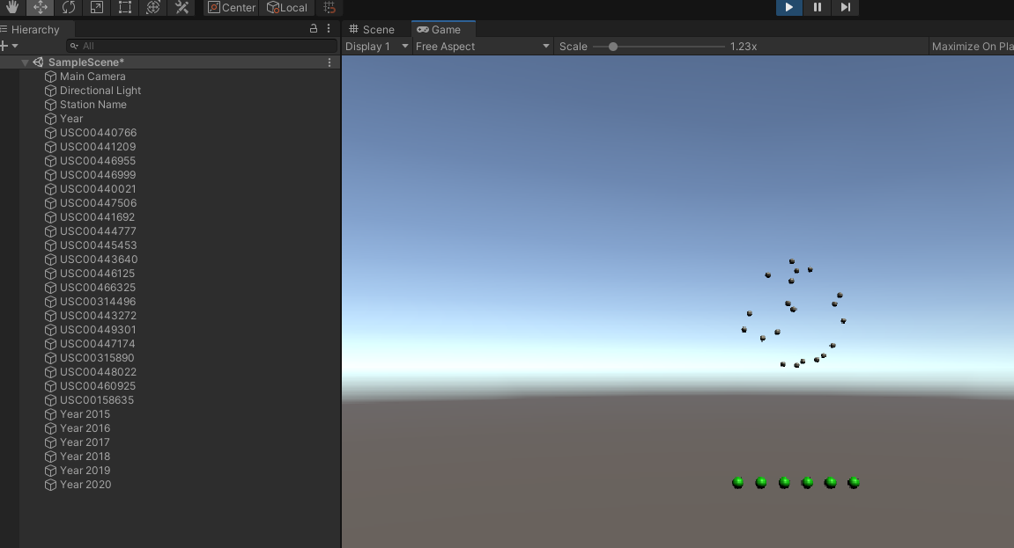

To Do:

For the next week, what I am planning to do is to add interaction to the project. I am planning to use colliders for adding clickability to all objects for selecting a specific weather station and retrieving a specific year of data. After that, I will use another form of visualization for rendering the retrieved data, but more on that later.